

IRIS BOX

Design By Alicia Sim



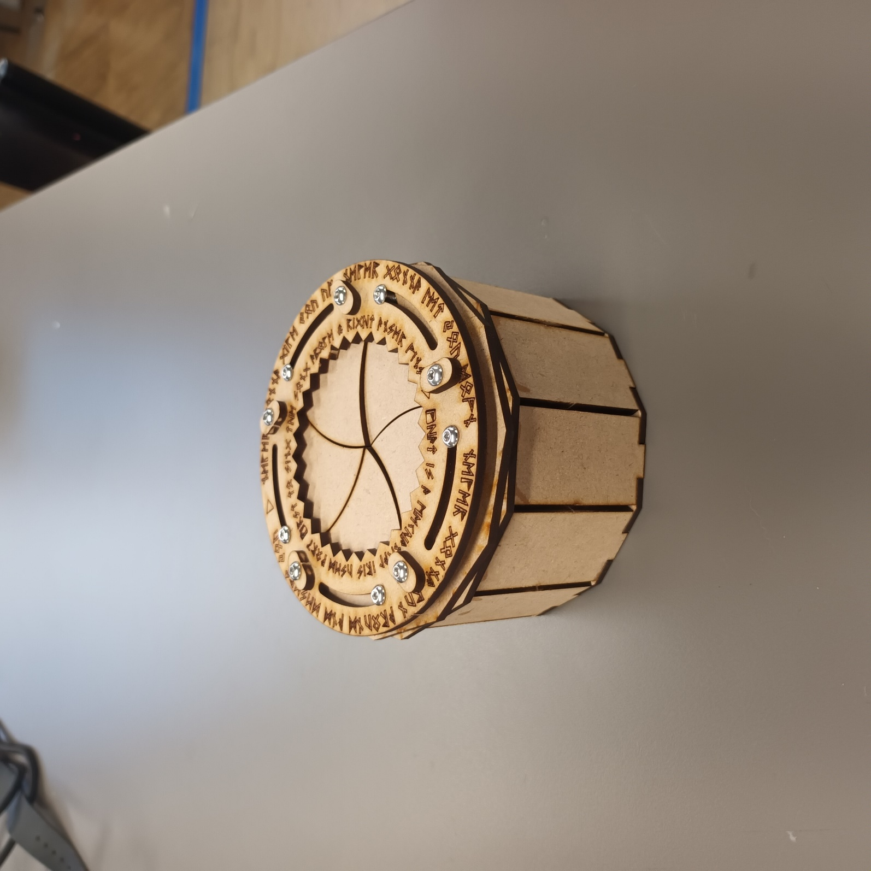

# Parts

|  |  |  |
| --- | --- | --- |
| Part | Image | Quantity |
| Small Square Piece |  | 6 |
| Spacer |  | 6 |
| Surrounding Plate |  | 12 |
| Triangular Plate |  | 5 |
| Riddle Plate |  | 1 |
| Code Plate |  | 1 |
| Bottom Mechanism Plate |  | 1 |
| Top Mount Plate |  | 1 |
| 10mm Bolt |  | 5 |
| 12mm Bolt |  | 5 |

# Tools

Wood Glue Sandpaper Hexagonal Screwdriver

# Assembly

Break/cut the pieces from the main board and sand them so the edges are smooth and there are no noticeable bumps. When assembling, aim to hide the burnt side.

↑

Spacer

← 10mm Bolts

← Riddle Plate

Take the Spacers and align the central hole to the holes in the Riddle Plate shown above. Then insert the 10mm screws into the holes and screw them in, do not tighten too tightly.

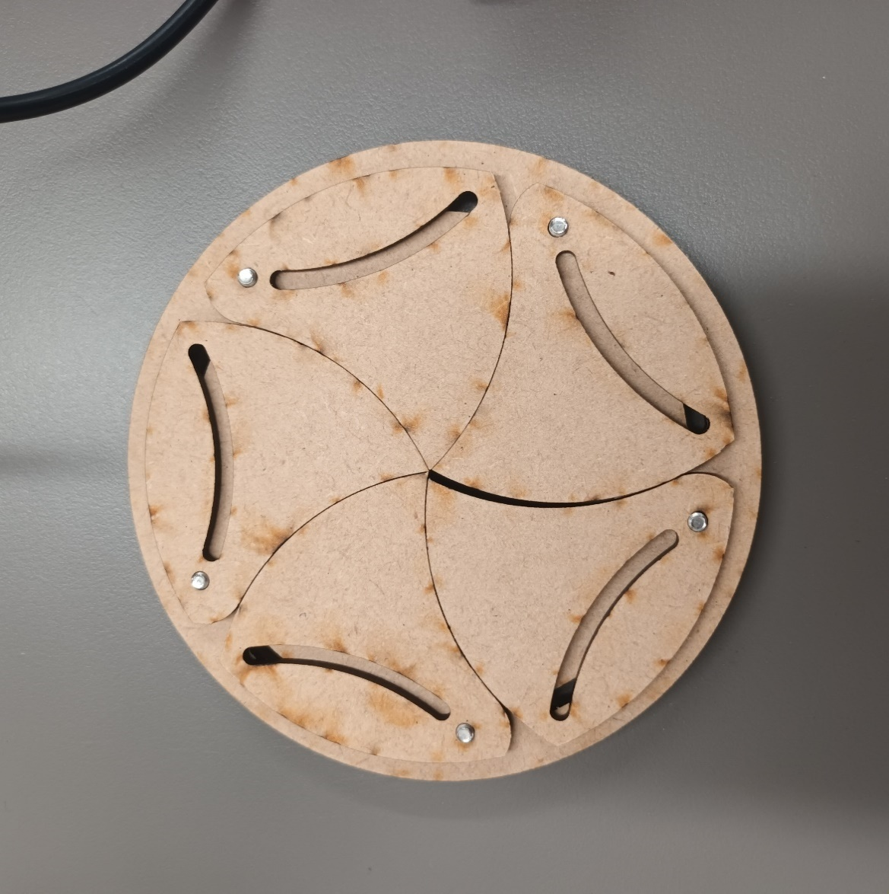



(Flip)

← Screw Through

← Triangular Plates

Flip the Riddle Plate and align the Triangular Plates as shown on the image. The holes in the top corners of the Triangular Plates should align with the holes on the Riddle Board. Tighten the screws so they hold the Triangular Boards in place; do not secure too tightly.

← 12mm Bolts



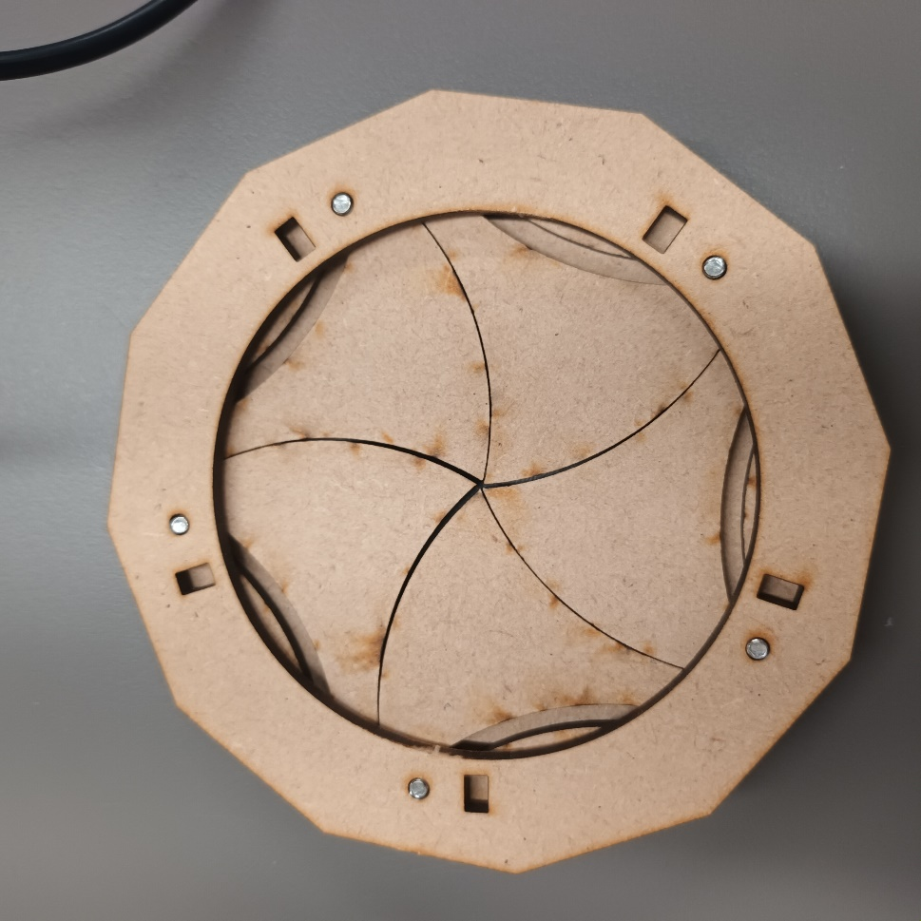

← Screw Through

(12mm Bolts)

← Bottom Mechanism Plate



Insert the 12mm bolts on the top of the Riddle Board, through the holes that align with the long holes in the triangular boards. Position Bottom Mechanism Plate so the holes align with the new 12mm bolts, then tighten the bolts so the Bottom Mechanism Plate is fixed to the mechanism.

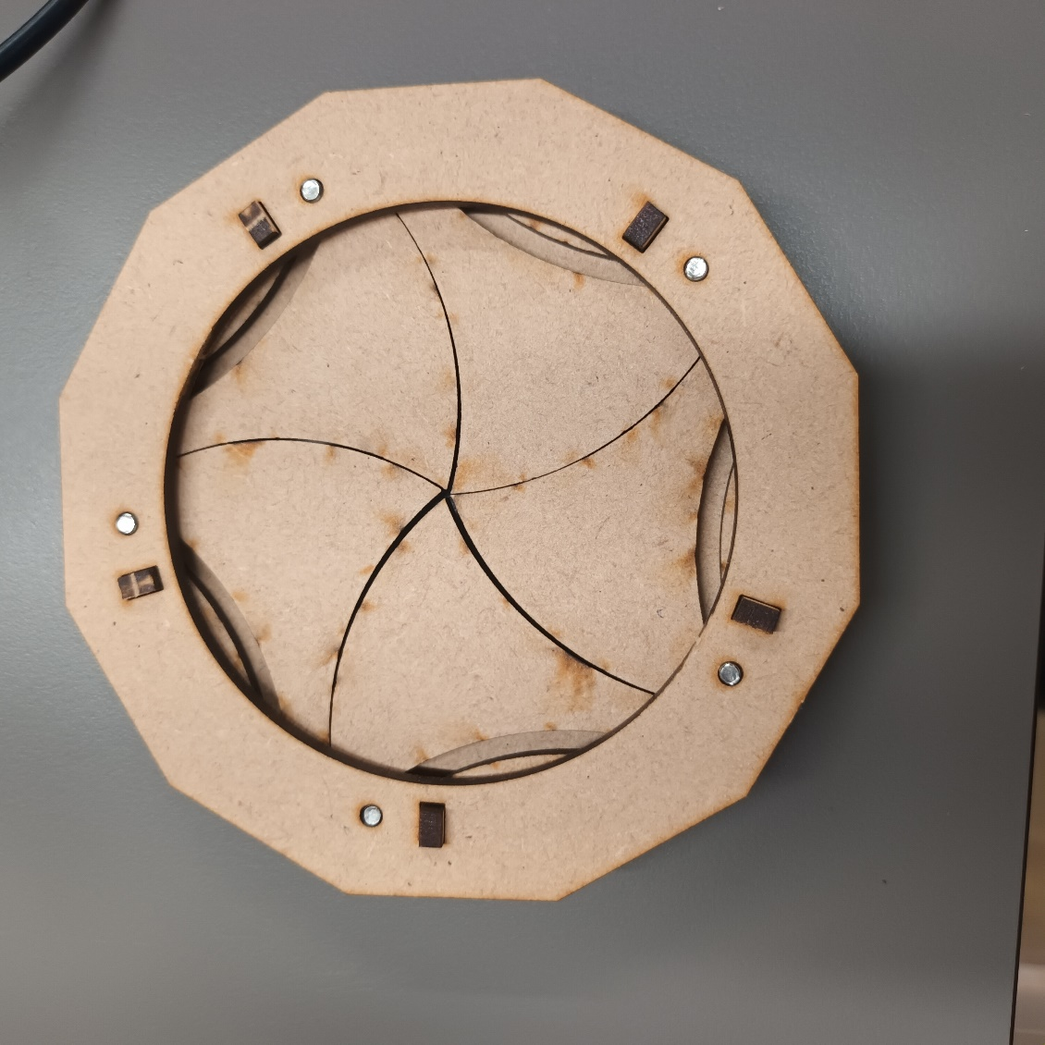

← Small Square Pieces

Insert the Small Square Pieces into the rectangular holes by the screws as in the image.

← Screw Through

← Top Mount Plate

← Wood Glue

Align the Top Mount Plate in a way that the Small Square Pieces fit into the rectangular holes, and the bolt holes on both plates are aligned. Screw the 12mm bolts through into the Top Mount Plate, but do not tighten too tightly. Place wood glue onto the Small Square Pieces to secure them.

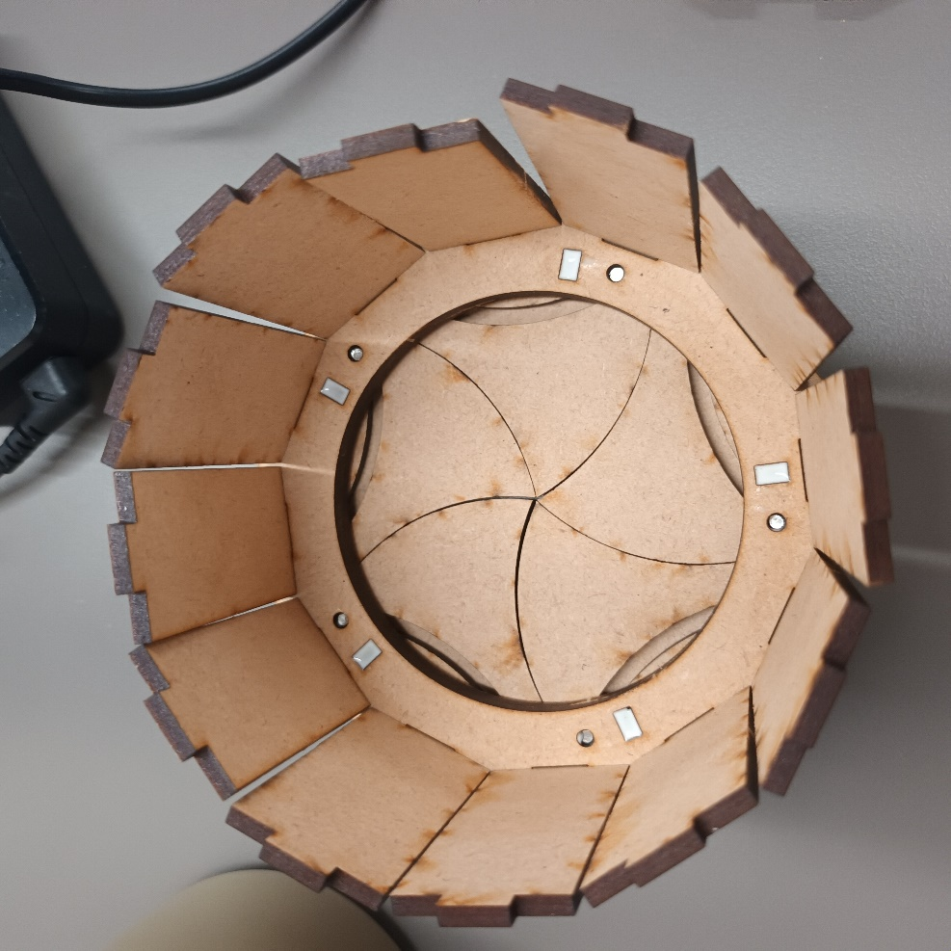

← Glue

← Surrounding Plates

Slot the Surrounding Plates into the remaining rectangular holes, like in the image.

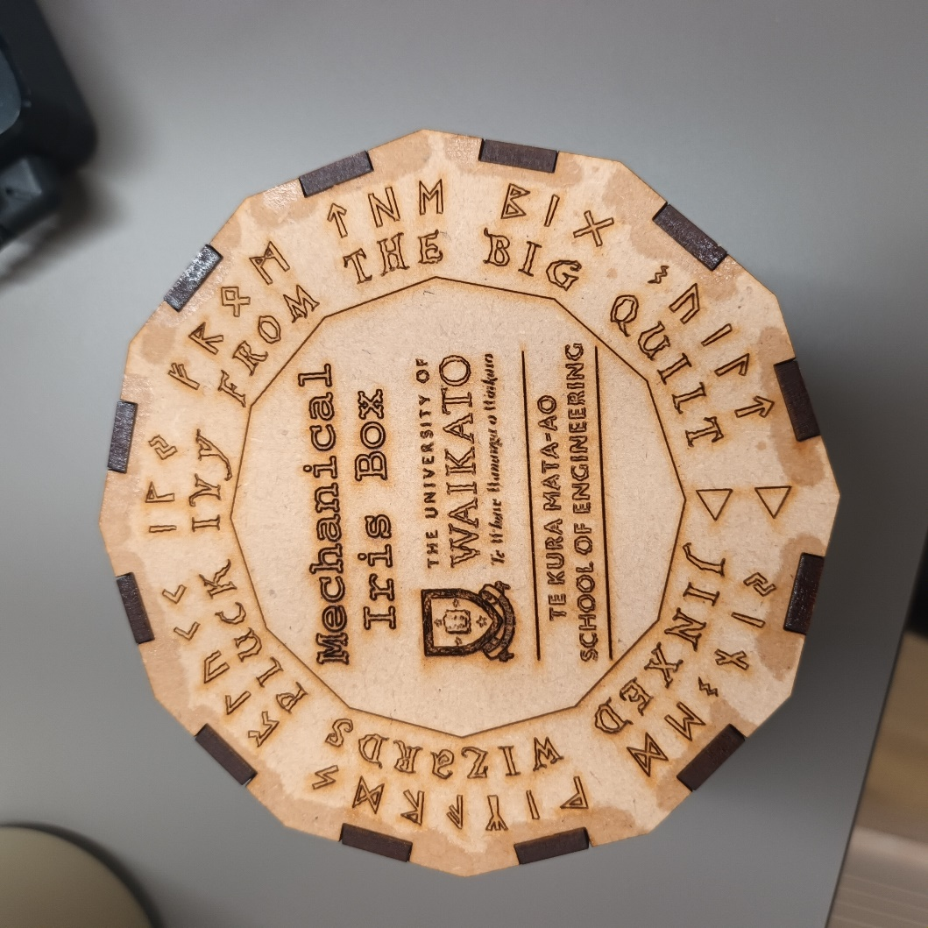

← Glue

← Code Plate

Place the Code Piece on top of the Surrounding Plates and slot the rectangular tabs into the holes of the Code Piece. Glue the top and bottom of the Surrounding Plates to fix them in place.

Voila!

# Troubleshooting

If the box does not rotate smoothly, the bolts are screwed too tightly.

There is one extra Spacer and Small Square Piece per kit.